**DAILY ONLINE ACTIVITIES SUMMARY**

|  |  |  |  |  |  |  |  |  |
| --- | --- | --- | --- | --- | --- | --- | --- | --- |
| **Date:** | **31 May 2020** | | | | | **Name:** | **Rani M D** | |
| **Sem & Sec** | **6th sem & B sec** | | | | | **USN:** | **4AL17CS075** | |
| **Online Test Summary** | | | | | | | | |
| **Subject** | |  | | | | | | |
| **Max. Marks** | |  | | **Score** | | |  | |
| **Certification Course Summary** | | | | | | | | |
| **Course** | **Machine Learning with python.** | | | | | | | |
| **Certificate Provider** | | | **Cognitive class** | | **Duration** | | | **13hours** |
| **Coding Challenges** | | | | | | | | |
| **Status: Executed** | | | | | | | | |
| **Uploaded the report in GitHub** | | | | | **YES** | | | |
| **If yes Repository name** | | | | | **Daily Status** | | | |
| **Uploaded the report in slack** | | | | | **YES** | | | |
|  | | | | |  | | | |

Certification Course Details: (Attach the snapshot and briefly write the report for the same

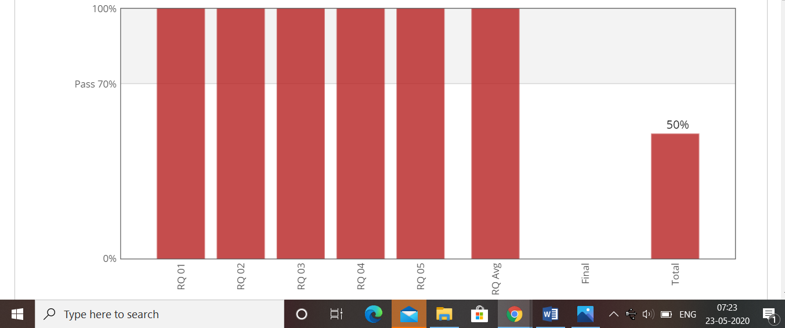

(31-05-2020)Machine learning with python.